**INTERNAL STYLING:**

**INPUT CODE**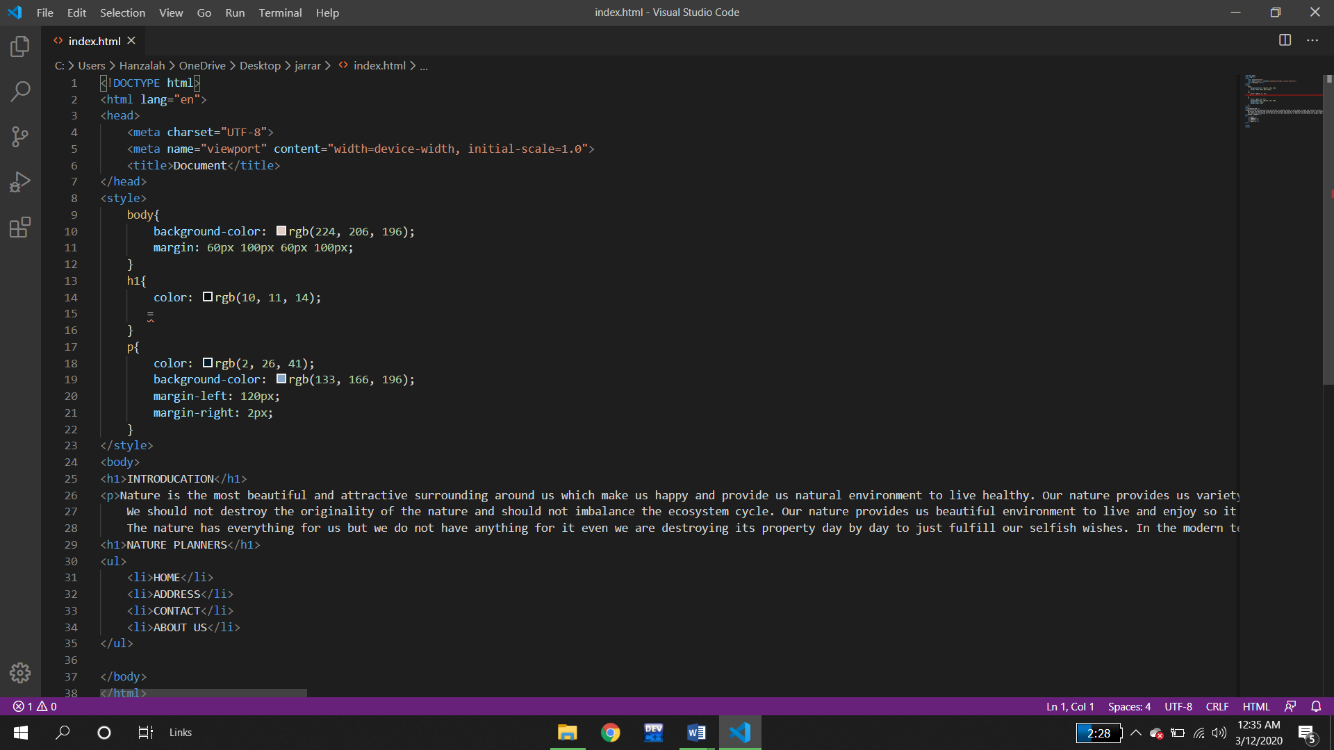

**OUTPUT**

